**Introduction**

**Background**: safety is the main priority when we decided to move in a new area. feel save is feeling which make you house that you name home. Security of family is very important when we consider purchasing new home.

P**roblem**. This project aims to select safe borough in Toronto base on total crime, explore the neighborhoods of the borough to find the 10 most venues in each neighborhood and finally cluster the neighborhoods using K-mean clustering

**Interest:** citizen who are considering relocating to Toronto will be interest to identify the safest borough in London and explore its neighborhood.

**Data Acquisition and cleaning**

**Data Acquisition**: The data acquisition of this project is combination of data from different source

The first data source of the project is Wikipedia data website. This webpage contains information about different Toronto borough.

Canada census: This is an official page for Canada census. Also, this page is continuously update.

Data cleaning

From Canada census bureau: the crime during the most recent year(2015) are selected. These crimes are sort in such we can have a broad preview on crime in different borough within Canada.

Second data from Wikipedia :using library python we can extract data in the tabular format as shown in the bebsite

**Methodology**

**Exploratory data**

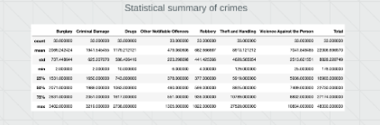

The count

Borough with the highest crime

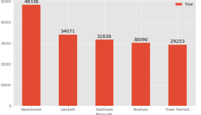

Borogh with lowest crime rate

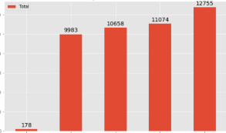

**Conclusion**

**\***This project help houser finder better undestand of neighborhoods with respect to most common venuesin the toronto city.It always good to be aware of the safety of the area before move or make a decision. Cost effect is very important.

**\***With this data many analysis can be done cast cost of living within toroto area .also, cluster ranking of education.